Melania Corradini: the Italian challenge at the 2006 Paralympics
Monday 8 November 2004: She is only seventeen, but she has the character and determination of a ski veteran
The Italian National Disabled Ski Team has a new promising young player. Her name is Melania Corradini and she is only seventeen, but she has the character and determination of a ski veteran. Her mission: to participate in the 2006 Torino Paralympics with the ambitious goal to win all four events. She has been skiing for almost ten years, and for just over a year has been with the world of disabled skiers. She descended her first slopes in the snow near her home in the Non Valley in the Trentino Region, and immediately took up competitive sports that turned her love for skiing into a full-fledged passion for the sport.
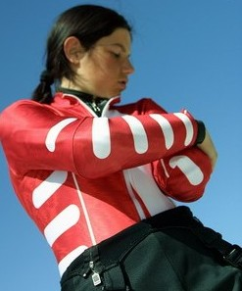
Melania Corradini (© Max Gualteri)
Her disability did not prevent her from skiing, and thanks to the Sportabili Company of Predazzo, she succeeded in finding her true place in sports. In fact, it was after a competition organised by them that the National Disabled Ski Team contacted her. Her commitment has grown ever since, and she began to train more frequently and more intensely. Since Melania joined the team of the Martin-Cazzaniga-Braido threesome, she has virtually not missed a single competition, and began with an excellent third place in the European Cup Super G. She achieved her best result in the stage at Artesina, where she came second in the Slalom.
She also participated in the World Cup where, although fortune was never on her side, she succeeded in obtaining second place in the finals of the European Cup freestyle descent at Sestriere. "Starting in September, I had the opportunity to train for three weeks in Stelvio", said the young Trentino woman, "but now I'll have the chance to get myself ready even better on the slopes of Torino 2006, since, thanks to the opportunity offered by the Lions Club to move to Oulx, I'll be able to ski and study at the same time".

A difficult training season awaits her, but now she will be able to practice at the very venues where she will be the protagonist in 2006: "The piste where the Paralympics will take place is demanding but very exciting at the same time. All those curves and gradient changes are very difficult and will need a lot of training". She will be busy starting December in the European Cup and the World Cup, and will also be facing long trips in the USA, Canada and Switzerland.
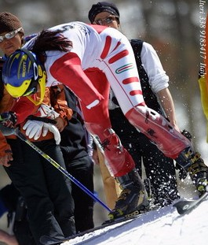
Melania Corradini (© Max Gualteri)
Her admittance to the National Team gave a substantial boost to the team both from a technical and moral point of view, since she has already become the favourite of the Olympic team due to her likableness and her enthusiasm. Team and fans expect a lot from Melania Corradini, and she will do all she can to live up to their expectations, to reach important personal goals and to bring results and medals to her national team.
Stefano Fiore

